**SHIVAJI UNIVERSITY, KOLHAPUR**

**A**

**Project Report**

**ON**

**“Fingerprint Door Access System By Using Arduino UNO”**

Submitted in partial fulfillment of the requirement for the degree of

**Bachelor of Engineering**

**In**

**MECHANICAL ENGINEERING**

By

1. **Pratiksha Shivaji Waghmare (18121104)**
2. **Shrutika Rajkumar Ammannavar (18121158)**
3. **Ashwini Gajanan Adhate (19123188)**
4. **Onkar Sanjay Kumbhar (18121260)**

**Under the Guidance of**

**Prof. K.S. Gharage**



**Department of Mechanical Engineering,**

**Government College of Engineering, Karad**

**Maharashtra State, India.**

**2021-2022**

**Government College of Engineering Karad**

Maharashtra State, India

**Vidyanagar, Tal:-Karad, Dist: Satara, Maharashtra, India**

**Phone: 02164-271711, 272414**

**E-mail:** [**principal.gcoekarad@dtemaharashtra.gov.in**](mailto:principal.gcoekarad@dtemaharashtra.gov.in)

**CERTIFICATE**

This is to certify that,

Ms. Pratiksha Shivaji Waghmare (18121104)

Ms. Shrutika Rajkumar Ammannavar (18121158)

Ms. Ashwini Gajanan Adhate (19123188)

Mr. Onkar Sanjay Kumbhar (18121260)

studying in B.Tech Mechanical has successfully completed the project entitled

**“Fingerprint Door Access System By Using Arduino UNO”**

under the guidance and supervision of Prof. K.S. Gharage during the academic year 2021-2022. This is a part of partial fulfillment of the requirement for submission of SHIVAJI UNIVERSITY, KOLHAPUR.

**Prof. K.S. Gharage Prof. (Dr.) R.K. Shrivastav**

Guide Professor and Head

Dept. of Mechanical Engineering Dept. of Mechanical Engineering

Govt. College of Engineering, Karad Govt. College of Engineering, Karad

**Dr. A.T. Pise Examiner**

Principal

Govt. College of Engineering, Karad

**ACKNOWLEDGEMENT**

We would like to express our deep and sincere gratitude to our Guide **Prof. K.S. Gharage**, Department of Mechanical Engineering, for guiding us to accomplish this project work. It was our privilege and pleasure to work under his able guidance. We are indeed grateful to him for providing helpful suggestion, from time to time. Due to his constant encouragement and inspirationwe are able to present this project.

We express our deep gratitude to **Dr.R.K.Shrivastav Sir**, Head of Mechanical Engineering Department, for his valuable guidance and constant encouragement. We are very much thankful to **Dr. A.T. Pise Sir**, Principal, Government college of Engineering, Karad for providing all the necessary facilities to carry out project work.

Last but not least we are thankful to our parents for their moral as well as financial support.

**ABSTRACT**

This project includes a smart and affordable door lock enhanced with a fingerprint interface a fingerprint sensor, gsm module, motor driver, a motor and some other hardware devices. The fingerprint sensor will be integrated in the door panel, facing outer side of the door, so that people can’t have access to the controlling system from outside. The latches will be fixed inside the door panel, so that the thickness of the door can help the latch’s strength. We’ll use a few latches within the panel to divide the force among them if tried to forced in. The fingerprint sensor will take the fingerprint of the user and forward it to the microcontroller to match with its records. If the print matches with one of the fingerprints of the microcontroller’s memory, the microcontroller will lock or unlock the latch, based on its current state. If the fingerprint is foreign to the microcontroller, the buzzer will buzz and the user will have to try again. If wrong fingerprints are tried 5 times at large, the system will text the owner to alert him/her about a break in. The system will also go into a secure state where it will continue to buzz the buzzer to alert the neighbors that something is wrong. The system will be reset once a known print will be entered

**Index**

1.List Of Figures

2.List Of Tables

|  |  |  |
| --- | --- | --- |
| **Sr. No.** | **Chapter** | **Page No.** |
| **1** | **Introduction** | 2 |
| 1.1 | Background | 2 |
| 1.1.1 | Door Access System | 2 |
| 1.1.2 | Arduino | 2 |
| 1.1.3 | Keypad | 4 |
| 1.1.4 | Finger Print Sensor | 5 |
| 1.1.5 | LCD Display | 6 |
| 1.1.6 | Magnetic Switch | 7 |
| 1.1.7 | Siren Circuit | 7 |
| 1.1.8 | Indicator | 8 |
| 1.2 | Motivation | 8 |
| 1.3 | Objective | 9 |
| 1.4 | Scope of Work | 9 |
| 1.5 | Organization Of Report | 9 |
|  |  |  |
| **2** | **Literature Review** | 10 |
| **3** | **Design Fabrication and Mechanism** | 17 |
| 3.1 | Project Process Flow | 17 |
| 3.2 | Project Activities | 18 |
| 3.2.1 | Identify Features/ Hardware to be used | 19 |
| 3.2.2 | Design Circuit and Identify Output Pins | 20 |
| 3.2.3 | Construct Circuit for Testing | 21 |
| 3.2.3.1 | Finger Print Scanner | 21 |
| 3.2.3.2 | LCD Display | 22 |
| 3.2.3.3 | Interface | 23 |

|  |  |  |
| --- | --- | --- |
| 3.2.4 | Understand Circuit Operations | 23 |
| 3.2.4.1 | Finger Print Scanner Circuit Operations | 23 |
| 3.2.5 | Create Coding Of Each Feature | 24 |
| 3.2.6 | Testing By ‘ Load And Run’ Program Of Each Feature Into Arduino | 24 |
| 3.2.7 | Build Prototype | 25 |
| 3.3 | Tools Required | 25 |
| 3.3.1 | Software | 26 |
| 3.3.1.1 | Arduino Programming | 26 |
| 3.3.1.2 | Fritzing | 28 |
| **4** | **Working And Testing** | 29 |
| 4.1 | Understanding The Working Principle | 29 |
| 4.2 | Enrolling Finger Print | 32 |
| 4.3 | Upload The Main Code | 33 |
| **5** | **Result And Discussion** | 35 |
| 5.1 | Finger Test And Matching | 35 |
| 5.2 | Safety Feature | 36 |
| 5.3 | Interfacing | 36 |
| 5.4 | Accuracy Test | 36 |
| **6** | **Conclusion** | 38 |
| **7** | **Future Scope** | 39 |
| **8** | **References** | 40 |

|  |  |  |  |  |
| --- | --- | --- | --- | --- |
|  |  |  |  |  |
|  |  |  |  |  |
|  |  |  |  |  |

LIST OF FIGURES

|  |  |  |
| --- | --- | --- |
| **Sr. No.** | **Title** | **Page No.** |
| Figure 1.1 | Door Access System- Process Flow | 2 |
| Figure 1.2 | Arduino UNO Board | 4 |
| Figure1.3 | Block Diagram – System Interface by Arduino | 4 |
| Figure1.4 | Fingerprint Scanner Process Flow | 5 |
| Figure1.5 | LCD Display | 6 |
| Figure1.6 | Magnetic Switch | 7 |
| Figure1.7 | LED | 8 |
| Figure 3.1 | Flow Chart Of project process flow | 18 |
| Figure3.2 | Flow Chart of Project activities | 19 |
| Figure3.3 | Hardware | 20 |
| Figure3.4 | Constructed Circuit Of Fingerprint Scanner | 22 |
| Figure3.5 | Constructed Circuit of LCD display | 22 |
| Figure3.6 | Constructed Interface circuit | 23 |
| Figure3.7 | Output from Arduino serial monitor | 25 |
| Figure 3.8 | Components required | 26 |
| Figure 3.9 | Arduino IDE development cycle | 27 |
| Figure4.1 | Optical Fingerprint sensor | 29 |
| Figure4.2 | Connection Of Sensor with Arduino | 30 |
| Figure4.3 | Enrolling Fingerprints | 32 |
| Figure4.4 | Uploading Code | 33 |
| Figure5.1 | Finger test Output at serial Monitor | 35 |
| Figure 5.2 | Final Product | 36 |
| Figure 5.3 | Result of accuracy test | 37 |

# LIST OF TABLES

|  |  |  |
| --- | --- | --- |
| **Sr. No.** | **Title** | **Page No.** |
| Table1.1 | LCD display pin description | 6 |
| Table2.1 | Different Biometric reorganization Technologies | 12 |
| Table2.2 | Comparisons Of existing door access system with Arduino based door access system | 16 |
| Table3.1 | Connections of Arduino output pins | 21 |
| Table3.2 | Function of each hardware | 27 |
|  |  |  |
|  |  |  |
|  |  |  |
|  |  |  |

**CHAPTER 1**

# INTRODUCTION

* 1. **Background**

**1.1.1 Door Access System**

Door access system is a type of control access system which control the opening and closing of the door. It is a system that is implemented on a building to keep the people and assets in the building to be safe from outsiders. The system is usually used during the activity of people entering and exiting the building. The door access system helps to differentiate unauthorized and authorized people as the system only allows the authorized person to enter the building. The door access system has two main features which are:- a) Keypad b) Fingerprint scanner To operate the system, these two features are interfaced with Arduino programming and the outputs are:- a) LCD display b) Magnetic switch c) Siren d) Indicator

Figure 1 illustrates the three main processes in the operation of the Door Access System – Arduino Based:- Figure 1.1: Door Access System – Arduino Based process flow

**1.1.2 Arduino** :

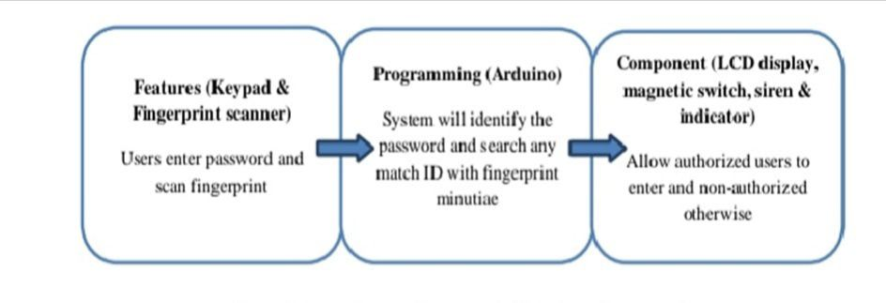

Figure 1.1: Door Access System- Arduino Based process flow

Arduino is an open-source physical computing platform based on a single microcontroller board. Arduino is used when there are interactions between inputs and outputs. It is used to control the output according to the inputs command such as controlling the light or motor by using a switch. The Arduino programming language uses Wiring which is an integrated development environment (IDE), and a single board microcontroller. The language can be expanded through C libraries. The advantages of using Arduino are:-

a) Inexpensive – Compared to other microcontroller boards, Arduino board is rather cheaper.

b) Cross-platform– Arduino software can runs on Windows, Macintosh OSX and Linux operating system. While most microcontroller systems can only runs on Windows only.

c) Simple, clear programming environment – Arduino is easy to use by beginners and advanced users.

In this project, Arduino is implemented by using the Arduino UNO as the microcontroller board as in Figure 1.2 It comes with an ATMEGA328 microcontroller whereby the program stored in ATMEGA 328 can be edited in the future for maintenance purposes. The inputs and outputs will be connected to the Arduino UNO I/O pins and interfacing is done by using Arduino software. Based on Fig 1.2, it shows the block diagram of the system interfaced by Arduino. Atmega 328 is the microcontroller which controls the inputs (keypad and fingerprint scanner) and outputs (LCD display, magnetic switch, siren and indicator.

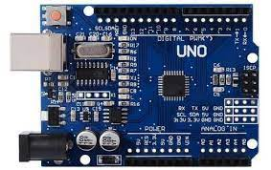

Figure 1.2 Arduino Uno

* + 1. **Keypad**

A keypad is a device used to enter the desired output. In this project a keypad matrix with 16 push buttons is used as shown in Figure 1.3. This type of keypad has four rows and four columns whereby the overlapping rows and columns are the keys as shown in Figure 1.3

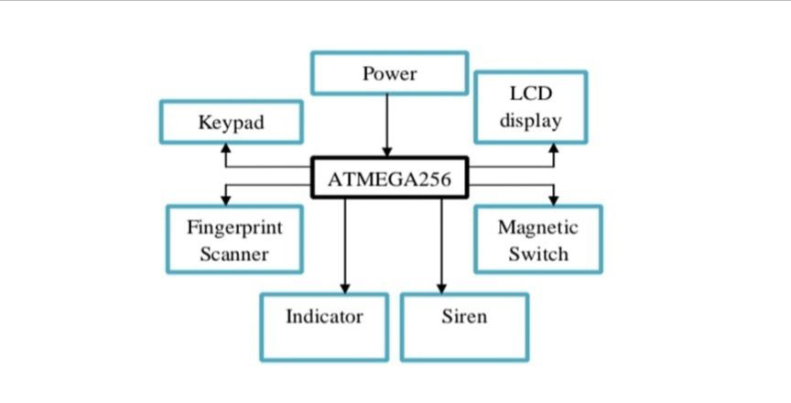

Figure 1.3: Block diagram of the system interfaced by Arduino

**1.1.4 Fingerprint scanner**

A fingerprint scanner is a type of biometric scanner which scans the human fingerprint. Its function is to capture the human fingerprint as in Figure 6. There are two types of fingerprint scanner which are optical and capacitive fingerprint scanner. The differences between these two types of fingerprint is that the optical fingerprint and capacitive fingerprint scanner captures minutiae by light and current respectively. In this project, the optical scanner is used because it is less accessible to electrostatic discharge (ESD) compared to capacitive fingerprint scanner. The fingerprint scanner is frequently implemented in control access system. The reason being is because every human have different fingerprint minutiae which helps in identifying the true data of a person accurately. In the case of door access system, the person who wishes to enter the building needs to scan their fingerprint to be Based on Figure 1.4, in this project the Adafruit fingerprint scanner used can cater up to 162 fingerprints. The stored fingerprints are stored in the onboard Flash Memory which has the size of 512 bytes. The fingerprint scanner process flow is shown in Figure 1.4

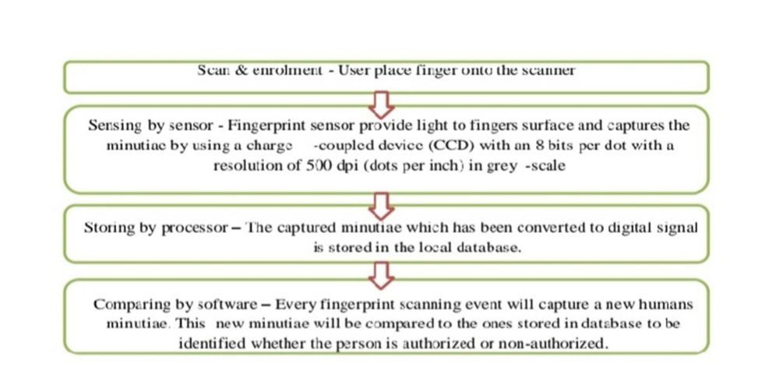

Figure 1.4 : Fingerprint Scanner process flow

**1.1.5 LCD Display**

A 16x2 LCD display which has 2 horizontal lines comprising a space of 16 displaying character is used in this project as shown in Figure 1.5. It has two types of registry inbuilt which are:- a) Command register that is use to insert command b) Data register that is use to insert data In this project ,the function of the LCD display is to displays the desired output according to the program.

Based on Table 1.1 ,each LCD pins has its own and it is connected to Arduino I/O digital pins.

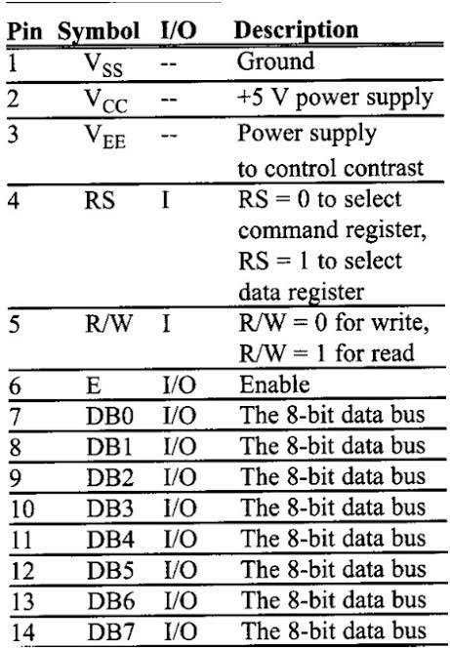

Figure 1.5 LCD Display

**1.1.6 Magnetic Switch**

A magnetic switch is a normally-closed dry contact that depends on magnetic field to operate. It applies relay working principle and control electrical switches by another switch. In this project the magnetic switch act as a magnetic door lock, whereby it is activated to lock the doors and it will be deactivated for the authorized users. It is also used as an intruder alarm to acknowledge the security guards on the presence of intruder. Figure 1.6 shows the magnetic switch, while Figure shows the schematic of magnetic switch. Based on Figure 1.6, there are two circuits in magnetic switch, which are:- a)Control circuit (in green) b) Load circuit (in red) During ON condition, the current flows through control circuit will produce magnetic field that would cause load circuit to be close (ON) as shown . Otherwise the load circuit will be open (OFF)

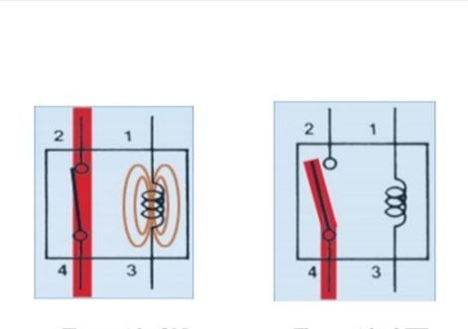

Figure 1.6 Magnetic Switch

**1.1.7 Siren Circuit**

A siren circuit is a circuit which produce siren by connecting the circuit to the speaker as output as shown in Figure 1.6. The function of the siren circuit in this project is to 8 produce siren at a certain basis.

There are two conditions that will activate the siren which are:-

a) Presence of intruder

b) Users inserted wrong password more than the allowable attempts

* + 1. **Indicator (LED)**

A light emitting diode (LED) is a semiconductor light source that as shown infigure 1.7act as an indicator. The red LED indicates door lock while the green LED indicates door unlock

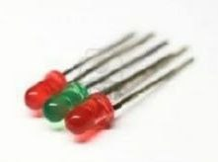

Figure1.7 LED

* 1. **Motivation**

Motivation behind this project is -

As the arduino uno is best hardware to create such project which very easy to use and work on it.

Arduino IDE software is open source software which is available for free.

Due to this two reasons coding compiling and uploading of code can be done in single software this is the main benifit

And now a days many security concerns are there for this purpose the fingerprint door access system will give more ease and secure functionality.

**1.3 Objective**

1. To study the functionality of fingerprint door access system with solenoid lock using Arduino UNO.

2**.** To create a door access system using Arduino approach.

3. To test the accuracy of this device.

4. To allows for more accurate tracking of workforce and provides additional security against the theft of sensitive materials.

**1.4 Scope of work**

1. To understand about door access system.

2. To understand about keypad.

3. To understand about biometric fingerprint scanner.

4. To study about Arduino and its application.

* 1. **Organization of report**

Among literature survey fingerprint door access system using arduino uno is selected.

As per specification the required components are collected

Assembly of components is done

In Arduino IDE software code get compiled and uploaded in arduino unoFingerprints enrolled. Then checking of validation of enrolled fingerprint using solenoid

**CHAPTER 2**

# LITERATURE REVIEW

This chapter gives a review of the literature related to this project work. Give the detailed literature review by grouping the literature in different categories and in chronological order.

Door access system has been widely used around the world. It is a type of security

system that is created to help in securing people and assets in a building from unwanted

cases such as burglaries and kidnapping. To develop a door access system, features or

hardware such as keypad, smart card, RFID card and biometric are implemented.

Besides hardware, software is also included in developing the door access system as it

Helps in interfacing the hardware and to have the desired system flow. Types of

Software or programming language being used in this system are PIC language

programming, Matlab, Microsoft Visual C++, Arduino and many more.

In this project, keypad and fingerprint scanner are implemented in developing the

Door Access System – Arduino Based. These two features were chosen because of its

user- friendly, smart and high security system compared to other features such as face verification, smart card, RFID card and many more.

Fingerprint scanner is a type of biometric sensors whereby it senses the human

Finger print for identification. Biometric consist of many types such as

Voice recognition, face-recognition, fingerprint-recognition and other identification

that consist of human body parts.

Based on a journal written by Wheeler et.al. (2000) on face-verification system, this

system is time-consuming to build because the users need to have more than one

images to separate ID and non-ID images for identification data storage purposes.

Despite of its advantages of identifying intra and interdependencies, it is proven that

this system is inefficient because it took 6 seconds to make decision while the aim is

within 2 seconds.

The fact of time-consuming system has also been said in a journal written by Ibrahim

Let. al. (2011) on face-recognition system. Face-recognition is difficult to build as there are alot of factor needs to be considered during image capturing which are illumination, distance and an individual’s head orientation. This system is also sensitive to aging and facial expression. It is also troublesome during experimental work asmany faces need to be taken at nine different angles.

Another access control system project by using voice-recognition system done by

Rashid et. al. (2008) is also a sensitive system as it will reject the voice input if there

are background noise

Cui et. al. (2009) agrees the fact of voice-recognition system being difficult. The

reason being is because it needs to build up a speech model whereby the users have

to pronounce the text according to the stated ones. Despite of its lacking in efficieny,

this project done by Bo Cui and Tongze Xue has its advantages compared to other

projects with similar feature by using a technology to filter low frequency disturbing

As compared to the fingerprint scanner used in this project, dring experimental work, the elements needs to be consider are the illumination and humans sweat that may appear on an individual’s finger. Implementing the fingerprint scanner produce a less time-consuming system as it can easily sense human fingerprint with a much higher

percentage of accuracy which is 70% for the left thumbprint The reason being is

because fingerprint scanner accuracy is only influenced less factor than face verification which are by human’s sweat and scratch surface of the scanner. Besides that the fingerprint scanner used in this project can make decision in less than 1 second.

The benefit of using fingerprint scanner was also said by Zhu et. al. (2011) in their

journal that fingerprint-verification overcome the issue of losing ID card where in their project is car keys. Another advantage is that the ownership can never be passed to other people . An optical fingerprint scanner is implementedin this project compared to other biometric features is because it has more advantages as stated in Table 2.1

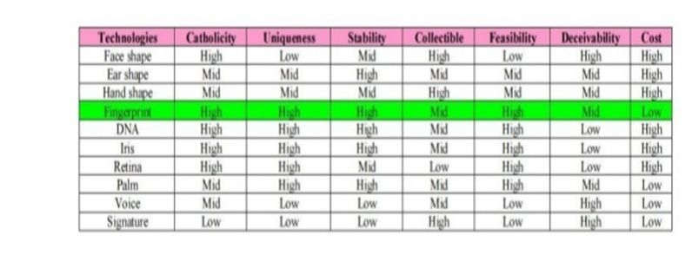

Table 2.1 Different biometric recognization technologies.

The quality of the scanned fingerprint is very important. To obtain a good quality

fingerprint, the fingerprint sensor senses the skin types and humidity of the fingergrain. The type of fingerprint used in this system is the optical sensor whereby optics sensor the CCD (Charge Coupled Device) .

In order to interface or have the system functioning, softwares and programming

language are used besides hardware. Project by Wheeler et.al. (2000) implements

MATLAB for face engine and Visual Basic for interface [13]. While project by

Ibrahim et. al. (2011) implements Microsoft Visual C++ and Visual Basic 2008

platforms for the application of Artificial Neural Network. Compared to Arduino

which is used in this project, it implement a simple yet can be used by an advanced

programmer to interface the hardware and develop the door access system

In terms of communications, Arduino is much more efficient as it communicates by

using USB cable compared to the project done by Rashid et. Al (2008) which uses

parallel port that is less speed.

Table 2.2 below shows the comparisons of existing door access system with Door

Access System – Arduino Based by its advantages and limitations of each system 2.2

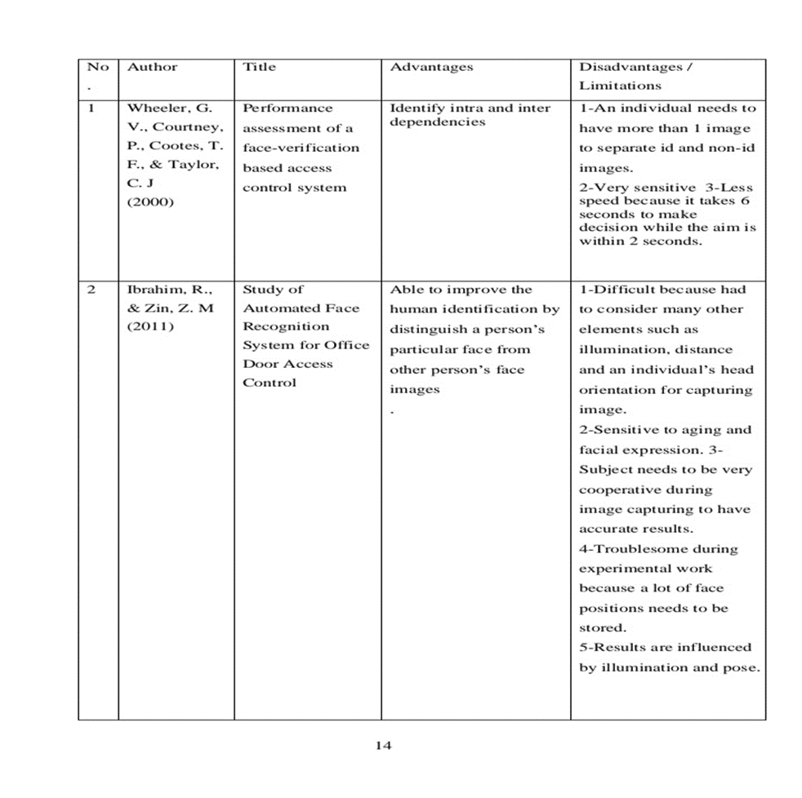

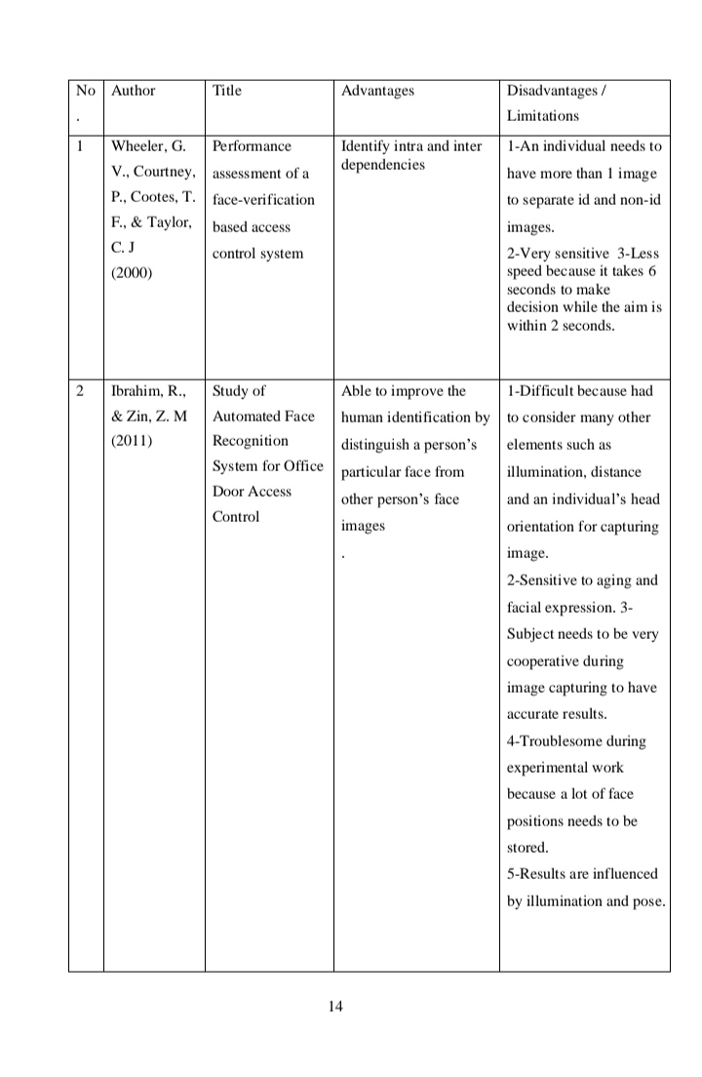

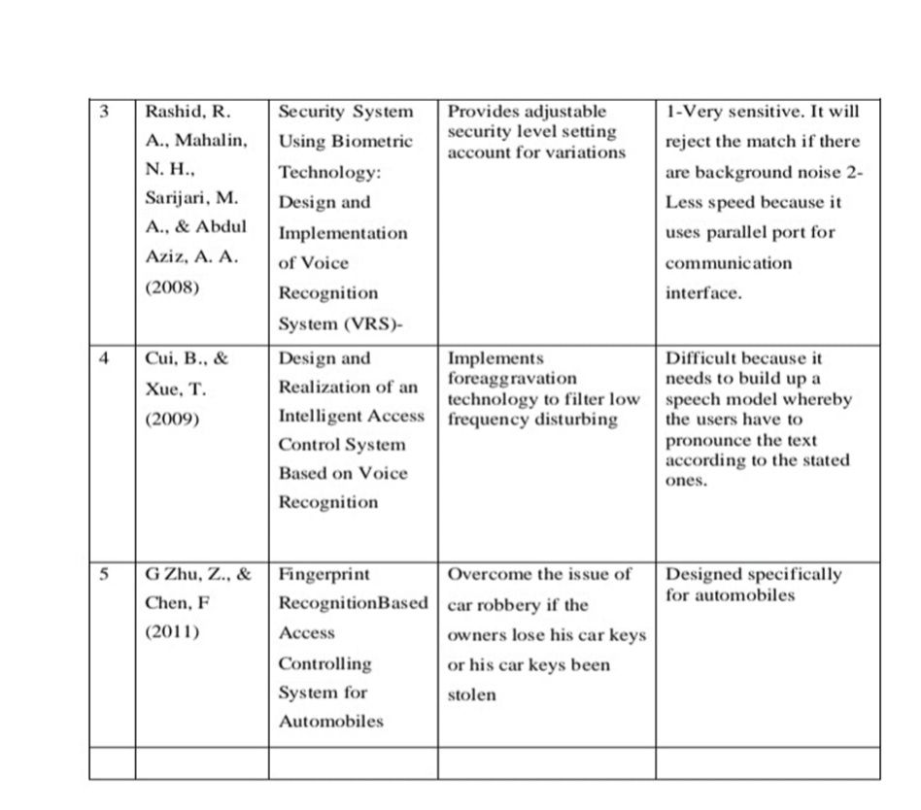

Figure 2.2Comparison of existing door access system with Arduino based door access system.

**CHAPTER 3**

# DESIGN, MECHANISM AND FABRICATION

**3.1 Project Process Flow**

The project process flow is illustrated as flow chart in Figure 16. Firstly the user will insert the password that has already been set by the system. If the entered password is correct, the user may proceed by entering their ID. Otherwise the user will be given three attempts to enter password. If wrong password is entered at the third attempt, alarm will be activated. Next, each authorized user have a template of their own fingerprint saved in the memory. In order to enter the building, the users need to scan their fingers by placing their finger onto the fingerprint scanner. During storing process for fingerprint scanner, the storing starts by enrolling the users ID. Once the users place their finger, the fingerprint scanner will capture the fingerprint. It will then extract the minutiae and store the output in memory. Next the process continues by finding the match. For fingerprint, it uses the stored minutiae with the ones that was recently capture. If the users minutiae matches their own minutiae which has already been stored before, the users may access the door as the magnetic door lock will be deactivated. Otherwise, the users have to enter their ID number again. The users will be given three attempts. If the users fail at third attempt, alarm will be activated indicating the presence of intruders.

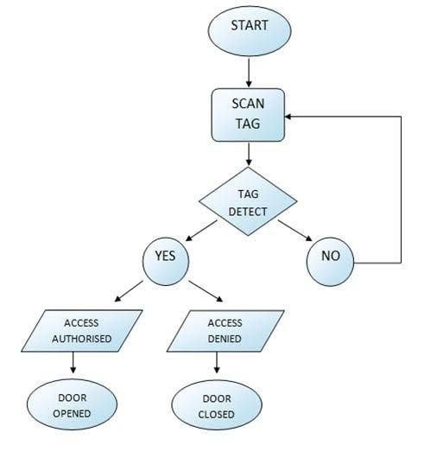

Figure 3.1 Flow chart of Project process flow

**3.2 Project Activities**

The project activities are done according to flow chart in Figure 3.2. The procedure shows the activity from the beginning of the project until it is completed

Figure 3.2 flow chart f project activities.

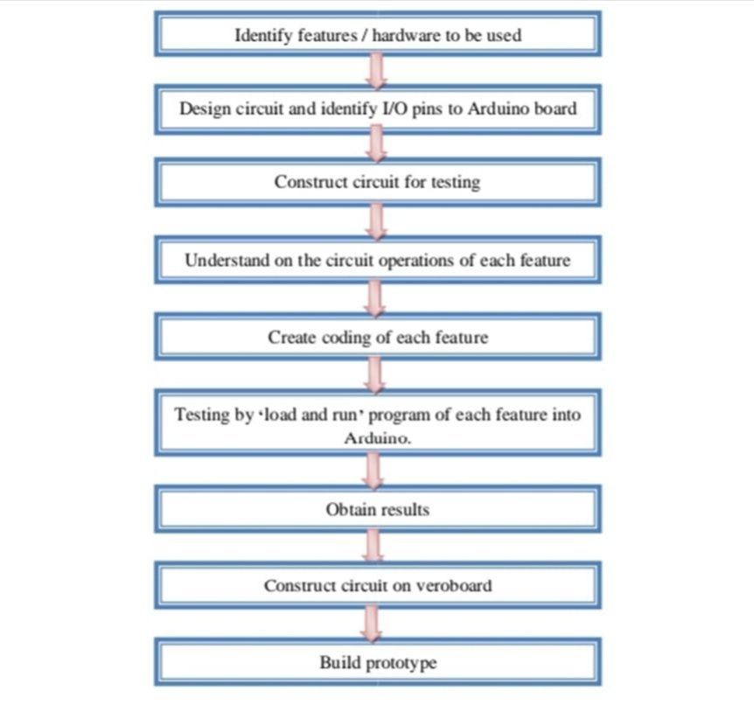

Figure 3.2 Flow Chart of project activities

**3.2.1 Identify features / hardware to be used**

Figure 18 shows the hardware used in this project. There are five main hardware which are 4x4 keypad, fingerprint scanner, Arduino Mega board and 16x2 LCD display. Keypad and fingerprint scanner are the features used to access the door. While the Arduino board platform is a platform that is designed to be used for testing by connecting the features to its I/O pins and uploading program to the Atmega 328 microcontroller. The function of LCD display is to display the output and the USB cable is used to communicate the Arduino programming language and the Atmel Atmega2560 microcontroller

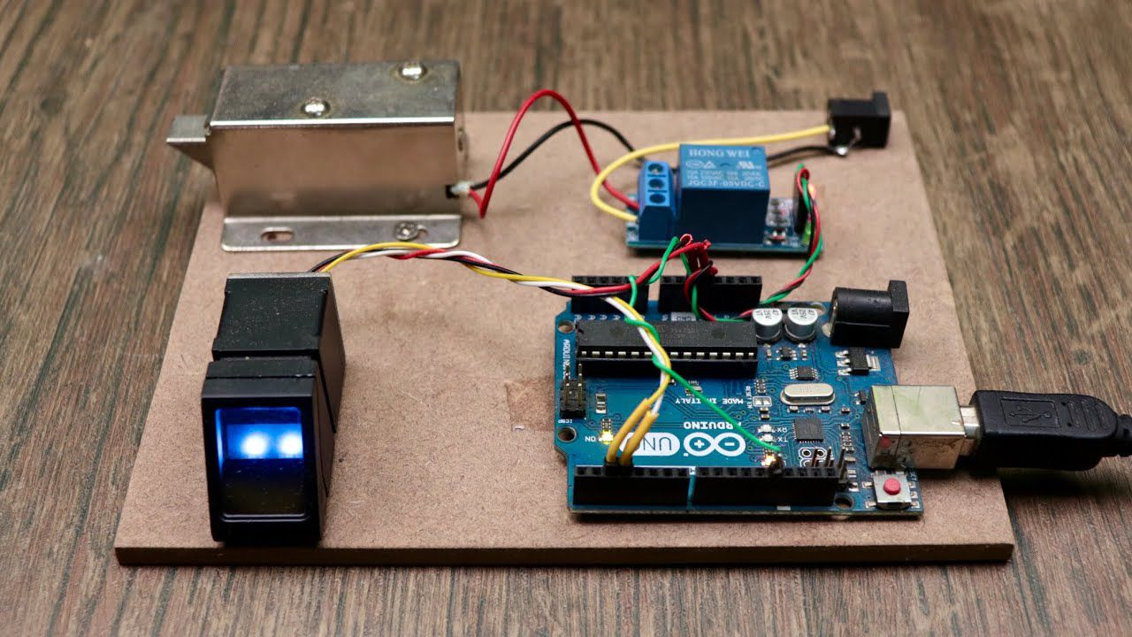

Figure 3.3 Hardware

**3.2.2 Design circuit and identify I/O pins to Arduino board**

The circuit diagram (Appendix A) of this door access system is designed by using Fritzing software which is a type of designing tools that supports Arduino. The connections of the features to Arduino I/O pins are shown in Table 4.

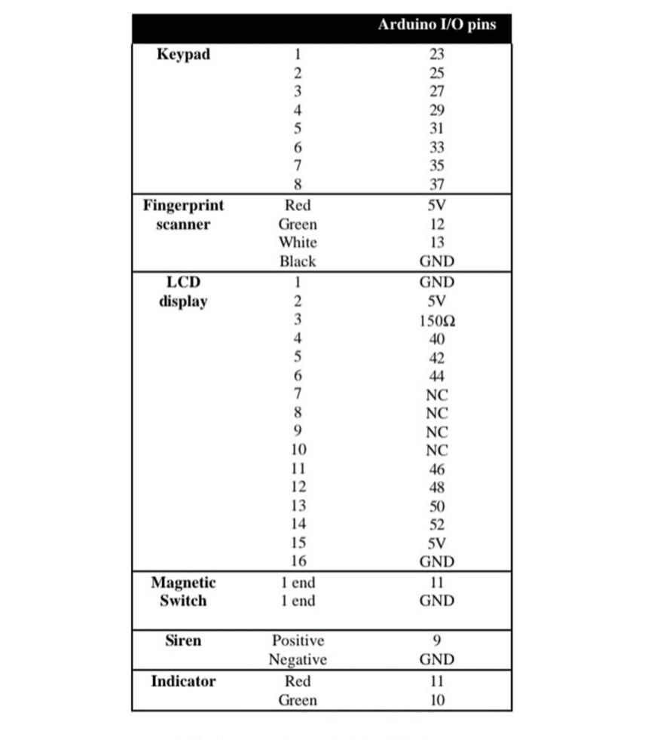

Table 3.1 Connections of Arduino output pins

**3.2.3 Construct circuit for testing**

**3.2.3.1 Fingerprint scanner**

The fingerprint scanner has 4 wires that can be connected to Arduino. Figure 3.4 below shows the circuit connection of it. The connections of fingerprints scanner to Arduino I/O pins can be referred to Figure 3.4 Constructed circuit of fingerprint scanner

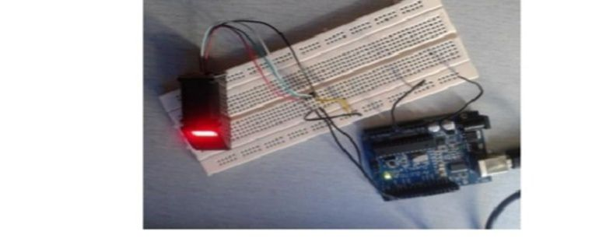

Figure 3.4 Constructed circuit of fingerprint scanner

**3.2.3.2 LCD display**

The LCD display is a 16 x 2 display. It is used to replace the Arduino IDE serial monitor to display the output. Figure 23 shows the constructed circuit of LCD display. The connections of LCD display to Arduino I/O pins can be referred to Table 4

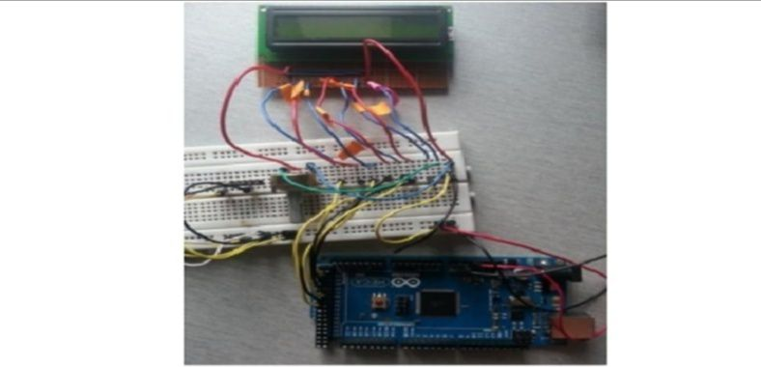

Figure 3.5 Constructed circuit of LCD Display

**3.2.3.4 Interface**

After testing the keypad circuit and fingerprint scanner circuit by interfacing with Arduino separately, both of the circuit are then combined together with LCD display Figure3.6 Constructed circuit of interfaced circuit

and Arduino to be interfaced. Figure 24 shows the interfacing circuit between keypad and fingerprint scanner with Arduino.



Figure 3.6 Constructed interface circuit

**3.2.4 Understand the circuit operations**

**3.2.4. 1. Fingerprint scanner circuit operations**

1. Arduino communicate with biometrics through UART. -UART (any voltage) -RS232 (+5 / -5)

2. D12→ for data flowing from Arduino to biometric sensor.

3. D13→ for data flowing from biometric sensor to Arduino.

4. The format of the data passing through D12 and D13 will follow the format in Figure 25.

5. The data contains in 8 bits. →1st bit – start of bit →end bit-stop of bit

**3.2.5 Create coding of each feature**

Since keypad and fingerprint scanner is the feature used in this project, therefore coding for these two features are created in the beginning. For fingerprint scanner it includes coding for enrolling and finger test. The output of the keypad and fingerprint scanner will be displayed using the serial monitor before it is displayed though LCD display. After each feature has its own programming, it is then been interface among the features itself. Below is the list of coding developed for this project. Refer Appendix C for coding.

1. 4x4 keypad coding

2. Fingerprint enroll coding

3. Fingerprint test coding

4. 4x4 keypad interface with LCD display coding

5. Password coding interface with LCD display

6. Fingerprint test interface with LCD display coding

7. Interface 4x4 keypad, fingerprint test and LCD display coding

**3.2.6 Testing by ‘load and run’ program of each feature into Arduino**

Testing are done after constructing each circuit and create coding. Before interfacing with LCD display, the output is displayed on the Arduino serial monitor. If the testing was a success, each circuit will be interfaced with LCD display to have the output on the display as shown in Figure 3.7 output from arduino serial monitor

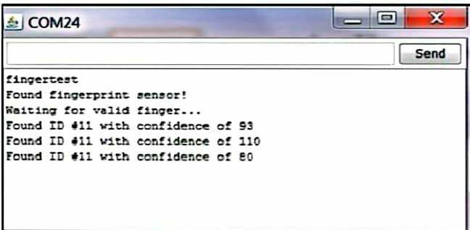

Figure 3.7 Output from Arduino serial monitor

**3.2.7 Build prototype**

The prototype is build to show the process flow of the system clearly as shown in Figure 3.8 It is designed with a door and a panel to insert the features which are keypad, fingerprint scanner and LCD display.

**3.3 Tools Required**

Figure3.8 Components required

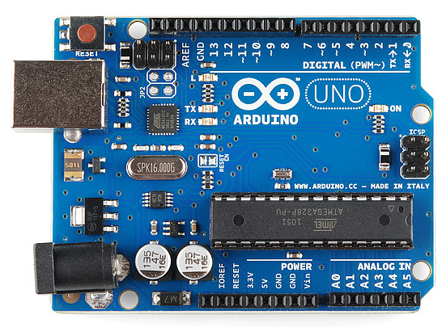

a) Arduino Uno

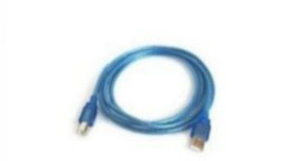

b) Connector

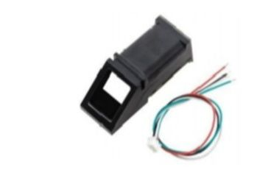

c) Fingerprint sensor

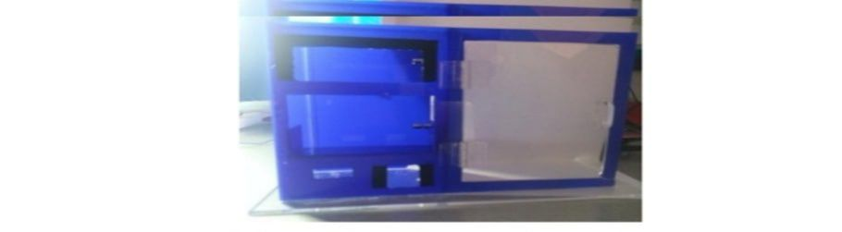

d) Door access system – Arduino based prototype

Figure 3.8 Tools required

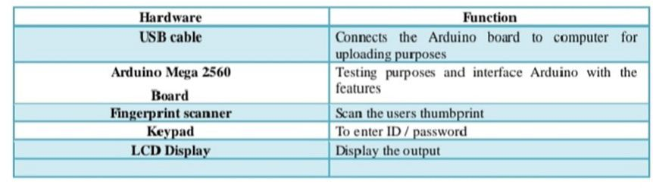 Table 3.2 Functions of each Hardware

**3.3.1 Software**

**3.3.1.1 Arduino programming**

Arduino is an open-source microcontroller. It can be edited and loaded to the microcontroller by using a USB cable. Arduino is an inexpensive type of singlemicroprocessor prototyping platform. The software consists of standard programming language, which is similar to C/C++. To run the program, Arduino comes with a bootloader that runs on the board. The reason of implementing Arduino in this project is because it has many advantages compared to other microcontrollers such as PIC. It is comes with an ATMEGA328 microcontroller whereby the program stored in ATMEGA328 can be edited in the future for maintenance purposes. Figure 3.5 shows the development cycle of Arduino IDE whereby it consist of editing the coding, compile, upload and run.

 Figure 3.9 Arduino IDE development cycle

**3.3.1.2 Fritzing**

Fritzing is software that supports Arduino. The libraries include components such as sensors and displays. The purpose of using fritzing is to design a circuit diagram virtually.

**CHAPTER 4**

# ASSEBLY, WORKING AND TESTING

**Components for assembly**

* Arduino Nano
* Fingerprint Sensor module
* Relay Module
* Breadboard
* voltage regulator
* Solenoid Lock
* Jumper wires
* 12V Adapter

**4.1 Understanding the Working Principle,**

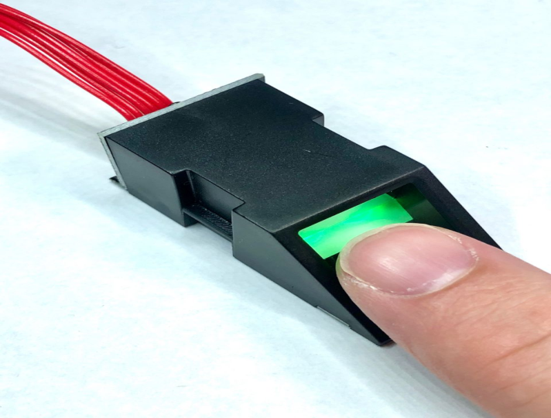

**Figure 4.1 Optical fingerprint sensor**

The fingerprint sensor we are using is an Optical Type, there exists two more types of sensor like capacitive which can be found in smart phones and ultrasonic ones, which are yet in testing phase, and both these options are expensive, so we will focus on this optical type for this hobby electronics and similar projects.

The way this optical fingerprint sensor works is that it captures a photo of our finger ridges, and then it uses certain algorithm to match it with stored data and displays result of the same.

few *features* of this sensor are as following:

* Power supply: DC 3.8V-7.0V
* Operating current: 65mA (Typical)
* Interface: UART (TTL logical level)
* Average searching time: <1s (1:500, average)
* Security level: 5(1, 2, 3, 4, 5(highest))
* Working environment:Temp: -20°C to +60°
* Touch area dimension: 14.5*19.4 mm
* Outline dimension: 54*20*20.5 mm

**Connect the Sensor with Arduino,**

[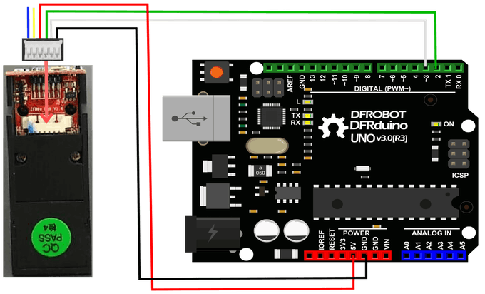](javascript:openLightBox('aa590fd0b1',%200);)

**Figure 4.2 Connection of sensor with arduino**

[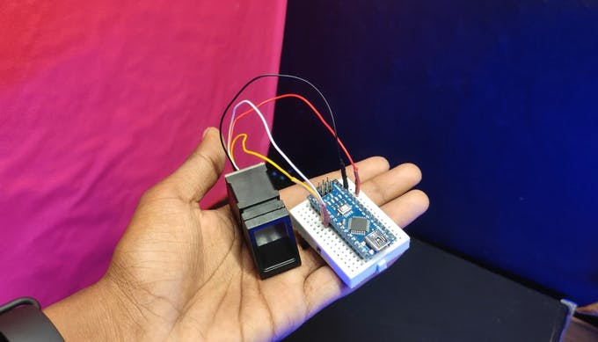](javascript:openLightBox('aa590fd0b1',%201);)

[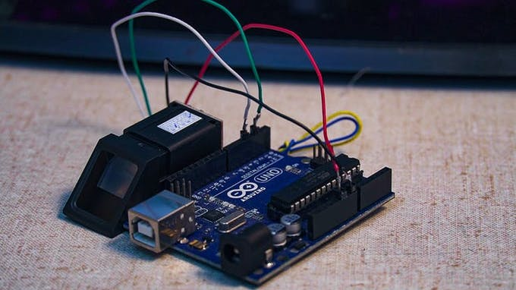](javascript:openLightBox('aa590fd0b1',%202);)

The connections part is very simple, this fingerprint sensor has 6 wires, out of which we only 4 wires are useful, for Arduino interfacing, out of which 2 wires will be used for power and 2 for data.

Connections:

* Red to 5v,
* Black to GND,
* Green to pin D2
* White to pin D3

Include the Adafruit Finerprint Library

To complete this project or tutorial, we will need "Adafruit's Fingerprint" library, which you can find attached in this step or Google it.

To install that library, follow these steps:

Add the library by selecting Add ZIP under *SKETCH*menu, *INCLUDE*Library options.

* Open arduino IDE
* Now, select the .zip file from the location where we downloaded the file

**4.2 Enrolling the Finger Prints,**

[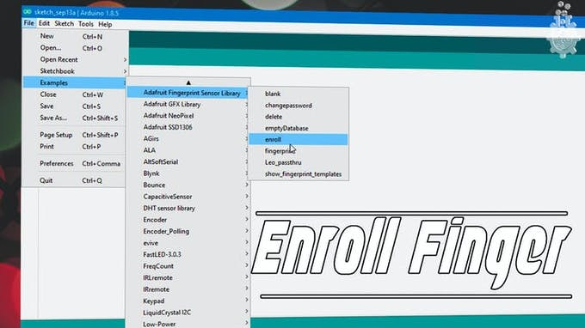](javascript:openLightBox('0fcb767609',%200);)

figure 4.3 Enrolling fingerprints

first process is to enrol the fingers into the EPROM of our Sensor module, so we will follow these steps to enrol our fingerprints.

select the enrol example.

* Open Arduino IDE
* Under the FILE menu, and Examples, find the Adafruit's fingerprint library.
* Upload the enrol example.
* Open the Serial Monitor.
* Select the baud rate to be 9600.
* Enter the Finger Print ID number when the serial monitor prompts to enter the fingerprint id number.
* Place the finger you need to enroll on the sensor.
* Place the finger again on the sensor once prompted by serial monitor.

**4.3 Upload the Main Code,**

[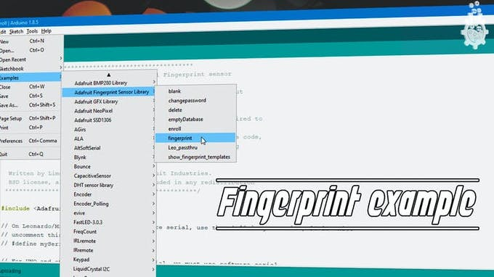](javascript:openLightBox('c4ad014c0c',%200);)

[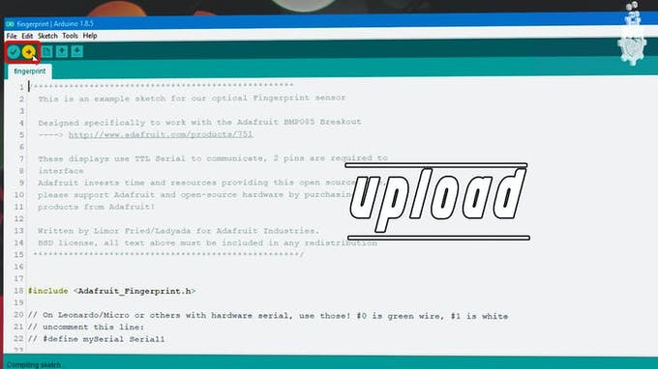](javascript:openLightBox('da66dc3474',%200);)

**Figure 4.4 Uploading the main code**

Since we enrolled the fingerprints in the last step, now we can test if this sensor works or may be check for match using this following code and steps.

* Open arduino IDE
* Under the FILE menu, and Examples, find the adafruit finger print library.
* Select the fingerprint example.
* Upload the fingerprint example.
* Open the Serial Monitor.
* Select the baud rate to be 9600.
* Place the finger you need to test on the sensor.
* Check for fingerprint id number for OUTPUT.

**Modify the Main Code to Interface LED ( or Solenoid)**

[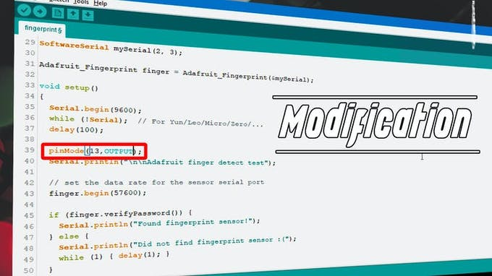](javascript:openLightBox('cfe66f9ff2',%200);)

**CHAPTER 5**

# RESULTS AND DISCUSSION

According to project activities flow chart, after constructing the circuit, testing was done. Figures 36 to 47 shows the results obtained from each feature and the interfacing all feature with Arduino. During testing, the outputs obtained were displayed through serial monitor. The LCD display is added afterwards to replace the serial monitor.

**5.1 Finger test and matching**

After enrolling the fingerprint, the stored minutiae need to be tested to test the accuracy of the fingerprint scanner. Figure 5.1 shows the finger test output at serial monitor. The user ID is found to be ID: 2. It states the confidence which actually measures the accuracy of the current scanned fingerprint and the ones stored in memory. The finger print scanner has a level of confidence from 0 to 255 which indicates from less accurate to very accurate. Figure 5.1 is a command display for the user to place their fingerprint. After scanned finger, Figure 5.1 shows the output being displayed at LCD display. The output indicates the current scanned fingerprint is matched with the stored minutiae with ID: 2.

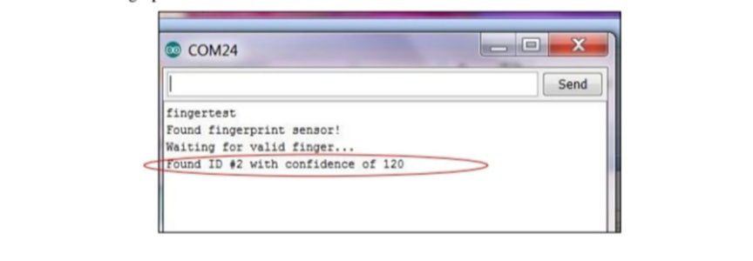

Figure 5.1 Example of output from Arduino serial monitor

**5.2 Safety Feature (Intruder Alarm)**

Intruder Alarm is added to acknowledge the safety guards of intruder. Figure shows the process flow on detecting intruder.

**5.3 Interfacing**

Figure 5.2 shows the final product. After all the features have been interfaced, it is then being placed together with the prototype.

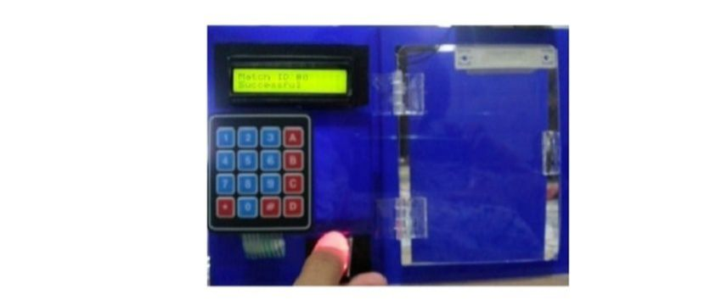

Figure 5.2 Final Product

**5.4 Accuracy test**

Accuracy test is performed to observe the security level of the fingerprint scanner. Figure 5.3 shows the result of the accuracy test based on the confidence level. The test was done on five individual with four thumbprints from each and one of them. The fingers scanned were, left and right thumbprint and also left and right index finger. From the result below, it shows that finger with the most accurate result is left thumbprint with the percentage of 70%, followed by right thumbprint, right index finger and left index finger with the accuracy of 67.2%, 41.4% and 30% respectively.

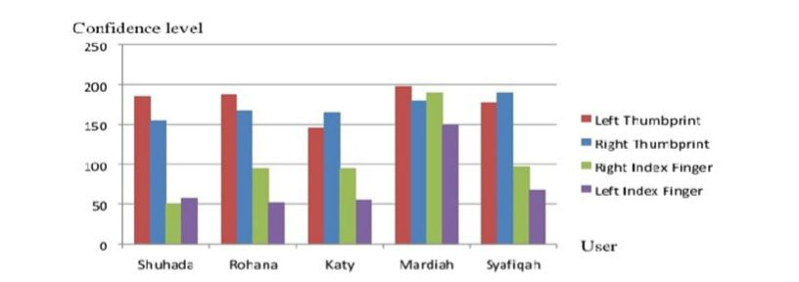

Figure 5.3 Result of accuracy test

**CHAPTER 6**

# CONCLUSION

The implementation of door access system is considered to be a need for a building especially companies to have a security system in order to keep the people inside and assets to be safe from unwanted cases such as burglaries and kidnapping. Tricubes Computer Sdn. Bhd. has been reported that the company’s existing door access system have problems in maintaining due to its obsolete components that could not be replaced. The Door Access System – Arduino Based is developed to overcome this issue as Arduino does not use a lot of components with the existence of the Arduino platform board and Atmel AVR microcontroller. The Arduino approach also overcome the issue of upgrading as it comes with an Atmel AVR microcontroller which can be edited and reprogrammed many times . Arduino is also known to its open source and cross-platform that could ease the task of a programmer. The software used in this project is Arduino programming language which is similar to C++. Based on the research done , it shows that Arduino is much simpler compared to other and suitable to be used in this project. Besides software and approach, this project also differs in terms of its features which are keypad and fingerprint scanner. It clearly shows that the features used in this project are more efficient compared to the existing system. There are two inputs used in this project which are keypad and fingerprint scanner. While the outputs are LCD display and magnetic door lock. The fingerprint scanner has also high accuracy with the percentage of 70% for the highest fingerprint. The fingerprint scanner used is in this project also have high efficiency due to its time in obtaining results identifying minutiae which is less than 1 second in identifying minutiae. For future work it is recommended to add another feature such as smart card to increase the security level. Smart card stores data such as name and ID of the owner and in future it can be used to match the entered ID using keypad.

**CHAPTER 7**

**FUTURE SCOPE**

Advancements in biometric identification management technology are moving so fast, In future we will make advancement and multi functions like sms alert if authorized person try to lock the door. Image recognizing process system and password system based. Also eyes retina for password which helps authorized persons for authentication for entrance so biometric technology makes individual convenient in real life.

# 

# CHAPTER 8

# REFERENCES

Meenakshi N, Monish M, Dikshit KJ, Bharath S. Arduino Based Smart Fingerprint Authentication System. In2019 1st International Conference on Innovations in Information and Communication Technology (ICIICT) 2019 Apr 25 (pp. 1-7). IEEE.

Baidya J, Saha T, Moyashir R, Palit R. Design and implementation of a fingerprint based lock system for shared access. In2017 IEEE 7th Annual Computing and Communication Workshop and Conference (CCWC) 2017 Jan 9 (pp. 1-6). IEEE.

Anu, Bhatia D. A smart door access system using finger print biometric system. International Journal of Medical Engineering and Informatics 2. 2014 Jan 1;6(3):274-80.

Afolabi A, Alice O. On Securing a door with finger print biometric technique. Transactions on Machine Learning and Artificial Intelligence. 2014 Apr 11;2:86- 96.

Gupta RP. Implementation of Biometric Security in a Smartphone based Domotics. In2018 International Conference on Advances in Computing, Communication Control and Networking (ICACCCN) 2018 Oct 12 (pp. 80-85). IEEE.

Baidya J, Saha T, Moyashir R, Palit R. Design and implementation of a fingerprint based lock system for shared access. In2017 IEEE 7th Annual Computing and Communication Workshop and Conference (CCWC) 2017 Jan 9 (pp. 1-6). IEEE.